**Soxhlet extraction**

In this method, the sample is extracted many times with a non-polar solvent such as hexane or petroleum ether (soxhlet system, figure 4). Thereafter, the solvent is evaporated and finally the extracted fat is weighed. With this method, most of the triacylglycerol fraction and the cholesterol in the meat are extracted, but only a fraction of the phospholipids and lipoproteins. With diethylether instead of hexane and petroleum ether, the yield from this method will be higher.

The Soxhlet Method can be performed in two different ways:

1. Without an acid hydrolysis. Triacylglicerol fraction is extracted.
2. With a previous acid hydrolysis. For that, HCl 3N is added on the sample and the mixture is heated for 1 hour. Triacylglicerol and phospholipids are extracted, and total fat can be determined.

It is possible to compare these methods by multiplying the results obtained in the first methodology by 1.2 (Wood and Enser, 1989).

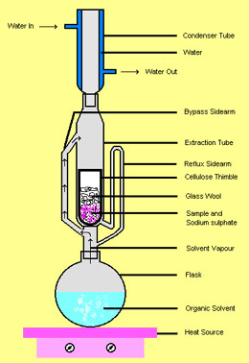

Figure 4 Soxhlet system.

Different solvents are required depending on the lipid that we want to extract. Tryglicerides can be extracted with a solvent such as diethyl ether. However, a more polar solvent is required to extract total lipids (phospholipids and tryglycerides together).

Table 1 Lipid (marbling fat) concentrations in m.longissimus and measures of eating quality in European studies comparing Durocs with other breeds as terminal sires (60-70 kg carcasses) (Modified from Wood, J.D., 1990).

|  |  |  |
| --- | --- | --- |
|  | (method of analysis)a | (method of analysis)b |
| **Denmark (Barton-Gade, 1987)c** |  |  |
|  | (method 2) | (Shear force measurements) |
| **Large White** | 1.31a | 91.2e |
| **Duroc** | 1.73d | 82.6d |
| **Hampshire** | 1.31e | 78.2d |
|  |  |  |
| **Irelant (McGloughlin *et al.,* 1988)f** |  |  |
|  | (Method 1) | (Taste panel scores)  J Fl T Oa |
| **Duroc** | 2.9 | 1.2 3.9 4.5 5.1 |
| **Large White/ Landrace** | 2.0 | 1.2 3.6 4.5 4.8 |
|  | *** | NS * NS NS |
| **UK (Edwards *et al.*, 1990)f** |  |  |
|  | (Method 2) | (Taste panel scores)  J Fl T Oa |
| **Duroc** | 1.8 | 1.3 2.1 -0.3 1.0 |
| **Large White** | 1.4 | 1.3 2.0 0.0 1.1 |
|  | *** | NS NS NS NS |

|  |
| --- |
| a Method 2 involves ether extraction alone; Method 1 also involves acid hydrolysis. Acid hydrolysis + ether extraction produces values approx. 1.2 x method of ether extraction alone. |
| b In Danish study, tenderness was measured objectively (as in Table 6). In Irish study, taste panellists used following scales: J, juiciness 0-4; Fl, flavour 0-5; T, tenderness 0-7; Oa, overall acceptability 0-7. UK taste panellists scored Fl, T and Oa -7 to +7 and J 0 to 4. |
| c,d,e Different superscrips within a column indicate significant differences (P is less than 0.05). |
| f * p is less than 0.05; *** p is less t |